Powered by GPT - Software Quality Verification
  - Final Report for Software Testing Course

System Under Test | Online Sales Management System
Repository | https://github.com/Alucard30Dec/Online-Sales-Management-System
Appendix Link | https://github.com/Alucard30Dec/Online-Sales-Management-System/tree/main/Report%20Test%20subject/SV00123-ATU-A01
Submission Date | April 11, 2026

Team Members
Name | Class | Student ID
Hoang Van Thien | 22D1ITE-SWE03 | 225051915
Nguyen Thanh Dat | 22D1ITE-SWE03 | 225050896
Le Quang Duy | 22D1ITE-SWE03 | 225051169

Record of Changes
Version | Date | Author | Change Summary
0.1 | 2026-04-05 | QA team | Completed project audit, submission structure, and test plan baseline
0.5 | 2026-04-05 | QA team | Added UI test cases, API test cases, test data, and automation design
0.8 | 2026-04-05 | QA team | Added automation implementation, execution evidence, defect workflow, and metrics
1.0 | 2026-04-06 | Hoang Van Thien | Consolidated final report content, analysis, and appendix linkage
1.1 | 2026-04-10 | QA team | Expanded verified UI execution evidence, refreshed metrics, and synchronized the report with the updated test case baseline
1.2 | 2026-04-11 | QA team | Removed UI Not Run status through real execution, refreshed defect log, metrics, report, and slides

Table of Contents
I. Overview
1.1 Project Information
1.2 System Under Test
1.3 Project Team And Task Allocation
Team allocation
II. Test Plan
2.1 Test Scope
2.2 Test Strategy And Approach
2.3 Test Environment
2.4 Tools Used
III. Test Design And Execution
3.1 Test Scenario Design
3.2 UI Test Case Design
3.3 API Test Case Design
3.4 Test Data
3.5 Automation Design And Implementation
3.6 Execution Summary
3.7 Execution Evidence
IV. Defect Report And Metrics
4.1 Defect Log
4.2 Defect Management Workflow
4.3 Test Summary Metrics
V. Conclusion And Future Work
5.1 Achievements And Compliance
5.2 Challenges And Limitations
5.3 Future Enhancements
5.4 Final Conclusion
References
Appendix
Appendix A. GitHub Submission Link
Appendix B. Key Attached Artifacts
Appendix C. Remaining High-Value Execution Gaps

I. Overview

1.1 Project Information
This report presents the final software-testing submission for the Online Sales Management System, an ASP.NET Core MVC (.NET 8) application that manages authentication, products, suppliers, customers, purchases, invoices, stock, reports, and a public product catalog. The project also exposes a small API surface for service health and public catalog access. The test submission was built directly from source-code inspection, seeded demo data, local execution, and evidence collected from the running application.
The main objective of this report is to verify whether the project behaves correctly for its business-critical workflows and whether the resulting artifacts satisfy the course rubric in test planning, test design, execution evidence, reporting quality, and automation readiness.

1.2 System Under Test
• Project name: Online Sales Management System
• Technology stack: ASP.NET Core MVC (.NET 8), EF Core, ASP.NET Identity, TiDB/MySQL
• Test surfaces:
• Admin UI
• Public Product Catalog
• GET /api/v1/health
• GET /api/v1/catalog/*

1.3 Project Team And Task Allocation
The project was completed by a three-member QA team. Work allocation was designed so each member owned more than ten UI test cases and covered separate functional areas to avoid unnecessary overlap. Hoang Van Thien handled a slightly larger portion of the workload and also led the integration of planning, automation direction, and final report consolidation.

Team allocation
• Hoang Van Thien
• led project audit and final integration
• owned 17 UI test cases
• main modules: Authentication, Permissions, Admin Users, Admin Groups, Invoices, Reports, partial Public Catalog
• Nguyen Thanh Dat
• owned 13 UI test cases
• main modules: Customers, Suppliers, Purchases, partial Stock
• Le Quang Duy
• owned 14 UI test cases
• main modules: Products, Product Import, partial Stock, partial Public Catalog
This allocation satisfies the requirement that each member contributes at least ten test cases while keeping role ownership visible for defense and review.
Member | Primary ownership | UI cases owned
Hoang Van Thien | Authentication, permissions, admin, invoices, reports | 17
Nguyen Thanh Dat | Customers, suppliers, purchases, partial stock | 13
Le Quang Duy | Products, product import, partial stock, public catalog | 14

II. Test Plan

2.1 Test Scope
The testing scope focused on the highest-risk business and control areas of the project:
• authentication and login validation
• role-based access control for admin, sales, and warehouse
• product and master-data management
• purchase creation, receiving, and cancellation
• invoice creation, payment flow, and cancellation
• stock visibility and movement history
• report filtering and summary totals
• public catalog browsing, filtering, sorting, and details
• health and catalog API behavior
The following items remained outside scope for this submission:
• performance and load testing
• deep security penetration testing
• mobile testing
• full responsive certification across multiple devices
• unrevealed write APIs outside the exposed public catalog and health endpoints

2.2 Test Strategy And Approach
The project used a mixed strategy of manual testing, API testing, and targeted automation. Manual testing was prioritized for broad business-rule coverage, permission behavior, validation feedback, and human verification of visible outcomes. API testing was used for stable request-response validation on the exposed endpoints. Automation was applied selectively to high-value flows to maximize bonus potential without overextending the scope into unstable or low-value areas.
Execution followed a black-box approach, while test design used white-box-informed analysis of the source code to identify hidden edge cases, validation rules, route behavior, and permission boundaries.

2.3 Test Environment
The verified execution environment was:
• OS: Windows 11
• Runtime: .NET 8
• Browser verified: Google Chrome
• Local base URL: http://localhost:5068
• Repository path: E:\Project\Online-Sales-Management-System
• Database environment tag observed in UI: TiDB / test
The test data environment relied on seeded demo data from Data/DbSeeder.cs, including valid accounts, products, suppliers, customers, purchases, invoices, expenses, and stock movement records.

2.4 Tools Used
• planning and traceability: Markdown + Excel-compatible CSV/XLSX artifacts
• UI testing: manual browser testing + Selenium WebDriver with .NET 8 and xUnit
• API testing: Postman and Newman
• bug management preparation: GitHub Issues taxonomy and defect register
• evidence and metrics: screenshots, TRX runner output, Newman output, CSV/XLSX metrics packs
Item | Value
Operating system | Windows 11
Runtime | .NET 8
Primary browser | Google Chrome
Base URL | http://localhost:5068
Database tag | TiDB / test
Repository path | E:\Project\Online-Sales-Management-System

III. Test Design And Execution

3.1 Test Scenario Design
The scenario design phase identified 42 documented scenarios across UI and API surfaces. These scenarios were grouped by module and risk type, including positive flows, negative flows, validation flows, permission checks, and business-rule edge cases. The design intentionally emphasized critical modules such as authentication, permissions, purchases, invoices, stock, reports, and product import.
At the current stage, all 42 documented scenarios are represented in the current test-case files, which gives a scenario design coverage of 100%. This closes the earlier traceability gap and strengthens the design section against rubric checks for completeness and coverage.
Scenario metric | Value
Documented scenarios | 42
Scenarios mapped to test cases | 42
Scenario design coverage | 100%
Scenarios with execution evidence | 42
Scenario execution coverage | 100%

3.2 UI Test Case Design
The UI test suite contains 44 test cases covering:
• authentication
• permissions
• admin users and admin groups
• customers
• suppliers
• products
• product import
• purchases
• invoices
• stock
• reports
• public catalog
Each UI test case includes:
• Test Case ID
• Scenario ID
• Title
• Module
• Preconditions
• Test Data
• Steps
• Expected Result
• Actual Result
• Status
• Owner
• Evidence / Note
The test cases were written to maximize clarity, reproducibility, and rubric coverage. Negative cases were prioritized for authentication, permissions, validation, duplicate inputs, import restrictions, and inventory-related workflows. In the current synchronized package, every UI case now has runtime evidence and no UI row remains in Not Run.
Test Case ID | Module | Preconditions | Expected Result | Actual Result | Status
TC-UI-AUTH-001 | Authentication | App is running; seeded admin account exists | Admin user reaches dashboard after valid login | Focused rerun reached the admin dashboard successfully | Pass
TC-UI-PUR-001 | Purchases | Warehouse or admin is logged in; valid supplier and product exist | Draft purchase is created and redirects to details page | Draft purchase was created successfully and redirected to details page | Pass
TC-UI-INV-001 | Invoices | Sales or admin is logged in; in-stock product exists | Invoice is created successfully and stock is reduced | Create action failed and returned to the form with error toast; server log confirmed backend exception | Fail

3.3 API Test Case Design
The API test suite contains 19 cases mapped to the real endpoints found in the source code:
• GET /api/v1/health
• GET /api/v1/catalog/products
• GET /api/v1/catalog/products/{id}
• GET /api/v1/catalog/trending
• GET /api/v1/catalog/filters
The API cases cover:
• smoke validation
• happy-path catalog queries
• validation and negative inputs
• boundary values
• detail retrieval
• not-found behavior
• lookup endpoints
The API workbook also includes an Evidence / Note column so each API case can point back to the Newman text output and XML runner artifact used for execution proof.
All API cases were derived from real routes only. No undocumented endpoint was added.
Test Case ID | Endpoint | Expected Status | Expected Result | Actual Result | Status
TC-API-HLT-001 | GET /api/v1/health | 200 | Health payload contains status, service, serverTimeUtc, version | Newman full run passed all health assertions | Pass
TC-API-CAT-004 | GET /api/v1/catalog/products?brandId=30039&page=1&pageSize=5 | 200 | Returned items match brandId=30039 or empty array without error | Request passed all Newman assertions in full run | Pass
TC-API-CAT-012 | GET /api/v1/catalog/products?sort=popularity&page=1&pageSize=5 | 400 | Validation error indicates unsupported sort option | Request returned expected validation status and passed Newman assertions | Pass

3.4 Test Data
The project uses seeded credentials and curated datasets to avoid generic placeholder data. Real reusable test data includes:
• valid seeded accounts for admin, sales, and warehouse
• invalid credential combinations
• category, brand, and product identifiers observed from the running system
• API query variations for positive and negative requests
• product import workbooks with mixed-validation rows
• invalid upload samples for attachment and file-format testing
Sensitive live credentials were not committed. Only demo-safe seeded data and controlled testing datasets were included in the repository.
Data group | Real source | Purpose
Seeded admin accounts | admin@osms.local, sales@osms.local, warehouse@osms.local | Auth, permission, purchase, invoice, report, and stock flows
Negative credentials | fake password / unknown email / inactive account placeholder | Invalid login and inactive-account scenarios
UI business data | prepared supplier, product, import, and form values | CRUD, purchase, invoice, and import execution
API query data | real category, brand, product IDs and negative query variations | Health and catalog API validation coverage

3.5 Automation Design And Implementation
To improve rubric score and bonus potential, a limited automation scope was implemented with maintainability in mind:
• UI automation stack: .NET 8 + xUnit + Selenium WebDriver
• API automation stack: Postman + Newman
• design pattern: Page Object Model
• reusable support layer for:
• configuration
• CSV test-data loading
• waits
• screenshots
• webdriver management
The selected UI automation flows were:
• admin login smoke
• sales access-denied navigation
• privileged-user draft purchase creation
• privileged-user invoice creation
• product import preview
The selected API automation groups were:
• health smoke
• catalog happy path
• catalog validation and negative cases
• product detail
• trending and filters
Automation surface | Implemented items | Evidence type
UI Selenium + xUnit | login smoke, permission denial, purchase draft creation, invoice creation, import preview | screenshots + TRX
API Postman + Newman | health, catalog list/detail, validation, trending, filters | Newman text output + XML
Reusable design | page objects, waits, screenshot helper, CSV loader, WebDriver factory | source code in TestScript-Data/Automation/

3.6 Execution Summary
As of 2026-04-11, the synchronized execution baseline now covers all designed UI and API cases with real runtime evidence:
• total test cases: 63
• executed: 63
• pass: 56
• fail: 7
• blocked: 0
• not run: 0
• execution progress: 100%
The strongest confirmed pass results now include:
• TC-UI-AUTH-001, TC-UI-AUTH-002, TC-UI-AUTH-004, TC-UI-AUTH-005, and TC-UI-AUTH-006
• TC-UI-ADM-001 and TC-UI-ADM-002
• TC-UI-CUS-001, TC-UI-CUS-002, and TC-UI-CUS-003
• TC-UI-SUP-001
• TC-UI-PRD-001, TC-UI-PRD-002, TC-UI-PRD-003, TC-UI-PRD-004, TC-UI-PRD-005, and TC-UI-PRD-006
• TC-UI-IMP-001, TC-UI-IMP-002, and TC-UI-IMP-004
• TC-UI-PUR-001, TC-UI-PUR-004, TC-UI-PUR-005, TC-UI-PUR-006, and TC-UI-PUR-007
• TC-UI-INV-002 and TC-UI-INV-004
• TC-UI-STK-001, TC-UI-STK-002, and TC-UI-STK-003
• TC-UI-REP-001 and TC-UI-REP-002
• TC-UI-PUB-001, TC-UI-PUB-002, and TC-UI-PUB-003
• all 19 API cases - full Newman collection pass
The current confirmed fail results are:
• TC-UI-INV-001, TC-UI-INV-003, and TC-UI-INV-006
• linked root defect: BUG-20260406-001
• invoice creation fails before reaching the intended business validation because of the known transaction defect
• TC-UI-INV-005
• linked defect: BUG-20260411-004
• invoice cancellation fails and stock is not returned
• TC-UI-IMP-003
• linked defect: BUG-20260411-003
• valid preview confirmation still fails during import commit
• TC-UI-PUR-002 and TC-UI-PUR-003
• linked defect: BUG-20260411-002
• purchase validation banner renders without readable text for two required-input scenarios
Final result summary | Value
Total test cases | 63
Executed | 63
Pass | 56
Fail | 7
Blocked | 0
Not Run | 0
Execution progress | 100%

Additional metrics | Value
Pass rate on executed cases | 88.89%
Fail rate on executed cases | 11.11%
Scenario count | 42
Mapped scenarios | 42
Executed scenarios | 42
Scenario execution coverage | 100%
Confirmed defects | 4

3.7 Execution Evidence
The current evidence set proves that both UI and API automation are functioning beyond a smoke-only baseline and now supports full case-level execution traceability:
• UI evidence
• login success screenshot exists for TC-UI-AUTH-001
• permission-denial behavior screenshot exists for TC-UI-AUTH-003
• import preview-count screenshot exists for TC-UI-IMP-002
• purchase details screenshot exists for TC-UI-PUR-001 and TC-UI-PUR-007
• invoice failure screenshot exists for TC-UI-INV-001
• extended execution screenshots now exist for admin users, customers, reports, stock, public catalog, and additional invoice, purchase, and product-import scenarios
• API evidence
• full Newman collection output exists for all 19 API requests
• server-log evidence
• extracted defect log exists for BUG-20260406-001
Figure E-1. Admin login success evidence.
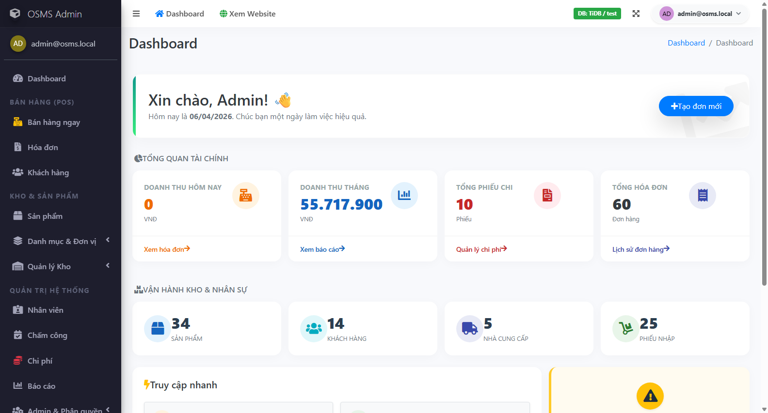
Figure E-1 - Admin login success

Figure E-2. Newman full-run summary snippet.
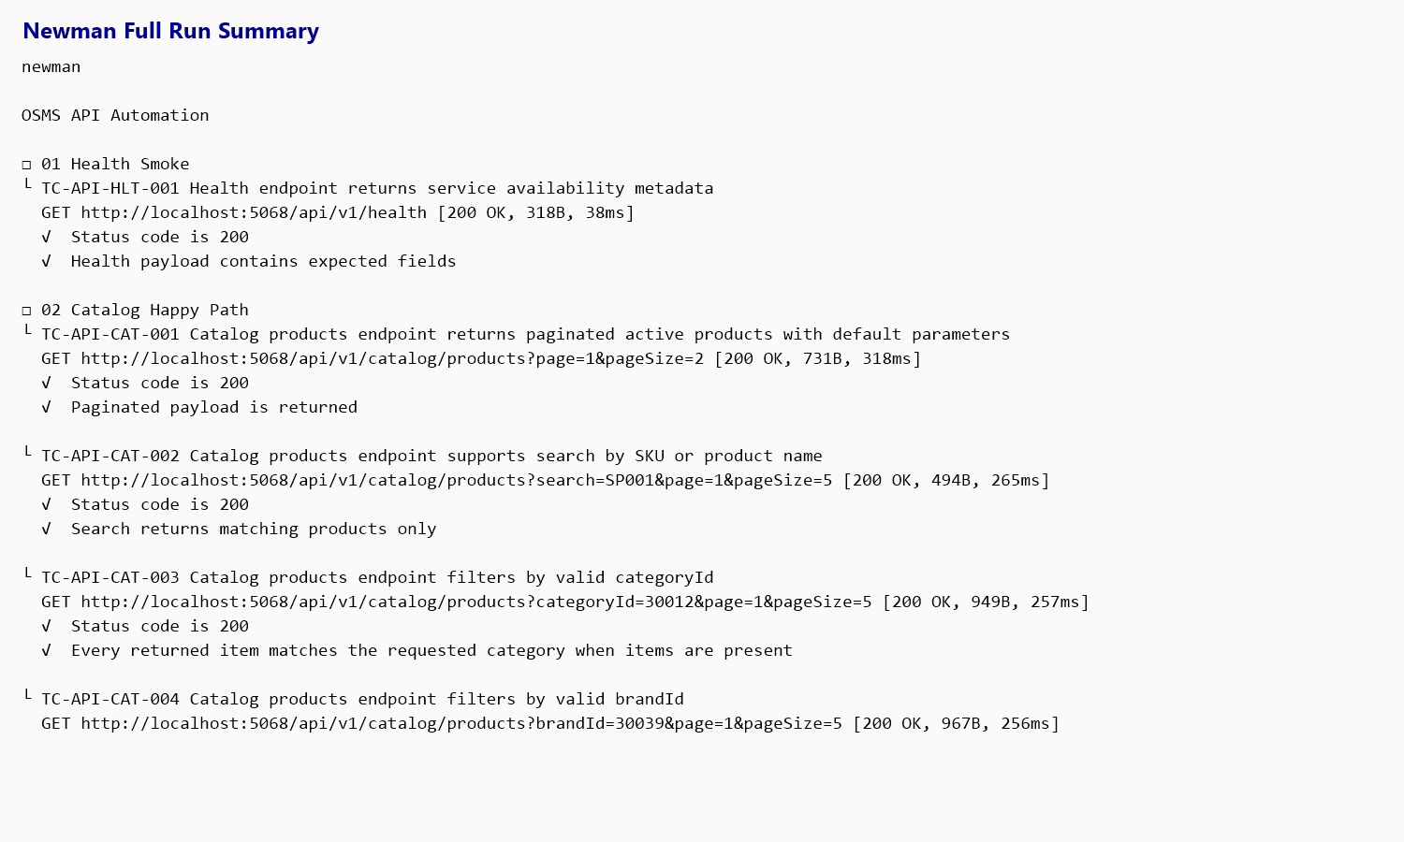
Figure E-2 - Newman full run summary

Figure E-3. Draft purchase creation success evidence.
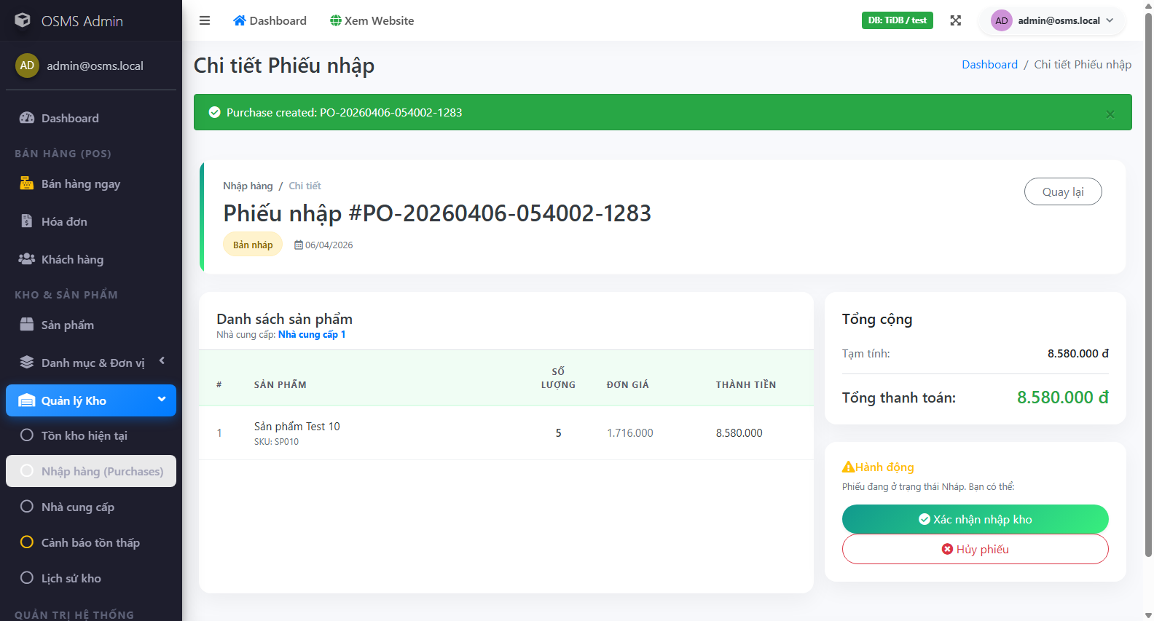
Figure E-3 - Draft purchase created

Figure E-4. Invoice creation failure evidence.
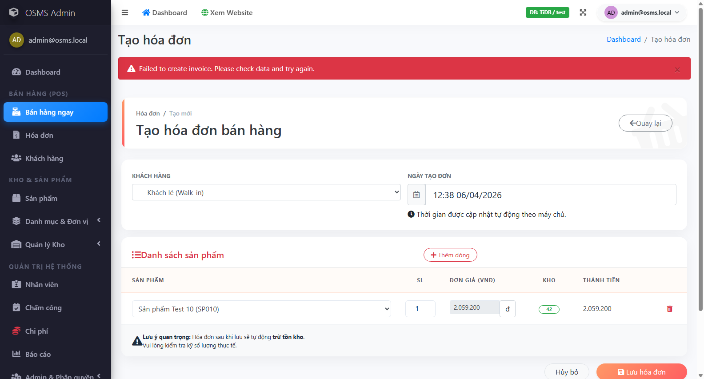
Figure E-4 - Invoice creation failure

Figure E-5. Permission-denial redirect evidence for sales user.
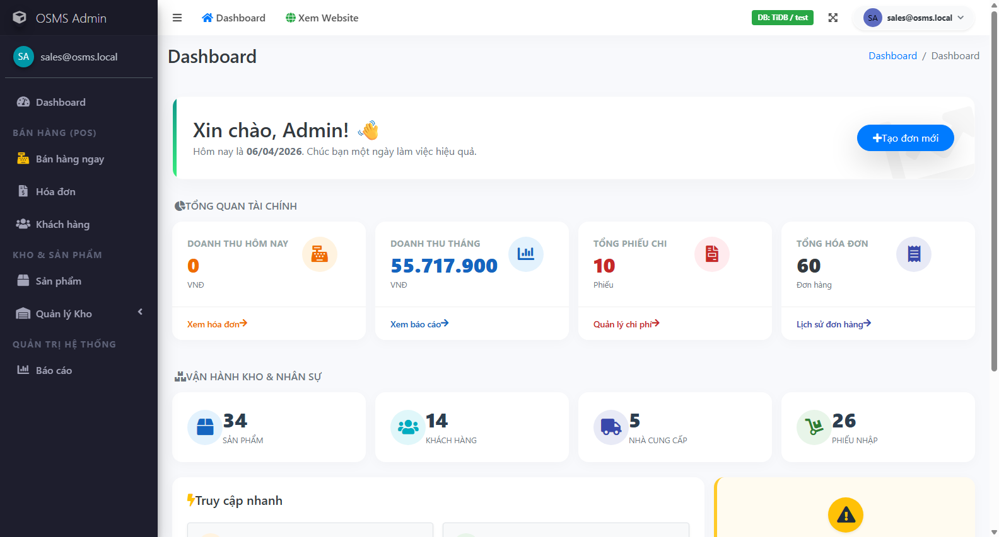
Figure E-5 - Permission denial

Figure E-6. Product import preview-count evidence.
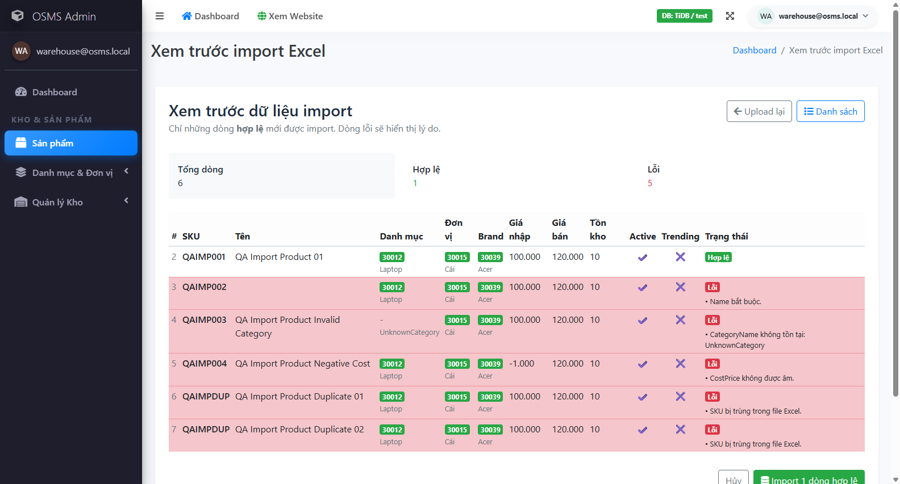
Figure E-6 - Product import preview

IV. Defect Report And Metrics

4.1 Defect Log
At the current reporting date, the repository contains 4 confirmed product defects and 0 open observations pending manual confirmation. The two older automation observations remain closed after focused reruns proved that they were automation or expectation issues rather than product defects.
Current confirmed defect records:
• BUG-20260406-001
• related to TC-UI-INV-001, TC-UI-INV-003, and TC-UI-INV-006
• module: Invoices
• severity / priority: High / High
• current state: Open - Confirmed
• GitHub Issue: #1
• GitHub URL: https://github.com/Alucard30Dec/Online-Sales-Management-System/issues/1
• evidence:
• UI failure screenshot
• focused rerun TRX
• extracted server log excerpt showing InvalidOperationException in InvoicesController.Create
• GitHub Issue screenshot with labels
• BUG-20260411-002
• related to TC-UI-PUR-002 and TC-UI-PUR-003
• module: Purchases
• severity / priority: Medium / Medium
• current state: Open - Confirmed
• evidence:
• two UI failure screenshots
• focused rerun TRX proving the validation banner is blank
• BUG-20260411-003
• related to TC-UI-IMP-003
• module: Product Import
• severity / priority: High / High
• current state: Open - Confirmed
• evidence:
• import-confirm failure screenshot
• focused rerun TRX proving the valid preview still fails on confirm
• BUG-20260411-004
• related to TC-UI-INV-005
• module: Invoices
• severity / priority: High / High
• current state: Open - Confirmed
• evidence:
• invoice-cancel failure screenshot
• focused rerun TRX proving cancellation does not complete
Record ID | Type | Related Test Case | Current Status | Evidence state
OBS-20260405-001 | Observation | TC-UI-AUTH-003 | Closed - Behavior Confirmed | rerun proved redirect-based denial is expected
OBS-20260405-002 | Observation | TC-UI-IMP-002 | Closed - Automation Fixed | rerun proved import preview works after locator fix
BUG-20260406-001 | Confirmed Defect | TC-UI-INV-001, TC-UI-INV-003, TC-UI-INV-006 | Open - Confirmed | UI screenshots, TRX, server log, and GitHub Issue #1
BUG-20260411-002 | Confirmed Defect | TC-UI-PUR-002, TC-UI-PUR-003 | Open - Confirmed | UI screenshots and rerun TRX
BUG-20260411-003 | Confirmed Defect | TC-UI-IMP-003 | Open - Confirmed | UI screenshot and rerun TRX
BUG-20260411-004 | Confirmed Defect | TC-UI-INV-005 | Open - Confirmed | UI screenshot and rerun TRX

Figure B-1. GitHub Issue evidence for the confirmed invoice defect.
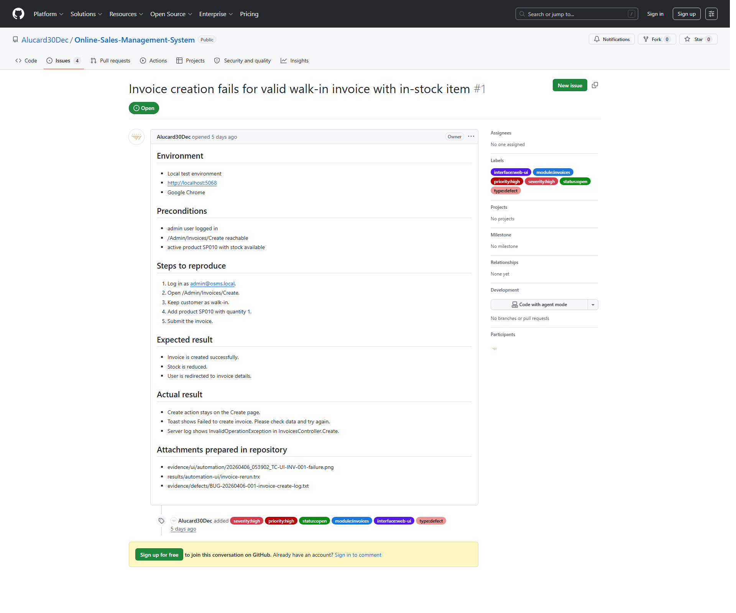
Figure B-1 - GitHub issue screenshot

4.2 Defect Management Workflow
The defect-management process was prepared using a GitHub-compatible workflow with explicit labels for:
• severity
• priority
• status
• module
• interface
• defect type
The intended workflow is:
1. execute or re-execute a related test case
2. classify the result as Confirmed Defect, Observation, or Automation Script Failure
3. open a GitHub Issue only after a defect is reproducible
4. attach screenshots, runner output, and expected-versus-actual details
5. retest before closure
Label group | Values used
Severity | severity:critical, severity:high, severity:medium, severity:low
Priority | priority:p1, priority:p2, priority:p3, priority:p4
Status | status:new, status:triaged, status:in-progress, status:ready-for-retest, status:closed, status:rejected
Module | module:auth, module:permissions, module:products, module:product-import, module:stock, module:purchases, module:invoices, module:reports, module:catalog-api, module:health-api
Interface / type | interface:ui, interface:api, interface:automation, type:defect, type:observation, type:automation-script

4.3 Test Summary Metrics
The current metrics show that the submission is structurally strong in planning, traceability, and execution completeness, while the main remaining weakness has shifted from coverage depth to unresolved defect count.
Key metrics:
• executed test cases: 63 / 63
• pass rate on executed cases: 88.89%
• fail rate on executed cases: 11.11%
• blocked rate on executed cases: 0%
• documented scenarios: 42
• mapped scenarios: 42
• scenario execution coverage: 100%
Interface-wise view:
• Admin UI
• total: 41
• executed: 41
• pass: 34
• fail: 7
• Public UI
• total: 3
• executed: 3
• pass: 3
• fail: 0
• API
• total: 19
• executed: 19
• pass: 19
Module-wise view now shows that every module has direct execution evidence. The public API surface is fully executed and stable in the current baseline. Invoices, Purchases, and Product Import still contain the current confirmed defects, while the remaining modules are currently stable under the executed cases.
Interface | Total | Executed | Pass | Fail | Not Run | Execution Progress %
Admin UI | 41 | 41 | 34 | 7 | 0 | 100
API | 19 | 19 | 19 | 0 | 0 | 100
Public UI | 3 | 3 | 3 | 0 | 0 | 100

Module | Total | Executed | Pass | Fail | Not Run | Execution Progress %
Authentication | 3 | 3 | 3 | 0 | 0 | 100
Permissions | 3 | 3 | 3 | 0 | 0 | 100
Purchases | 7 | 7 | 5 | 2 | 0 | 100
Invoices | 6 | 6 | 2 | 4 | 0 | 100
Product Import | 4 | 4 | 3 | 1 | 0 | 100
Stock | 3 | 3 | 3 | 0 | 0 | 100
Reports | 2 | 2 | 2 | 0 | 0 | 100
Public Catalog | 3 | 3 | 3 | 0 | 0 | 100

Coverage status | Scenario count
Executed | 42
Designed Only | 0
Total | 42

Figure M-1. Metrics summary exported from the workbook.
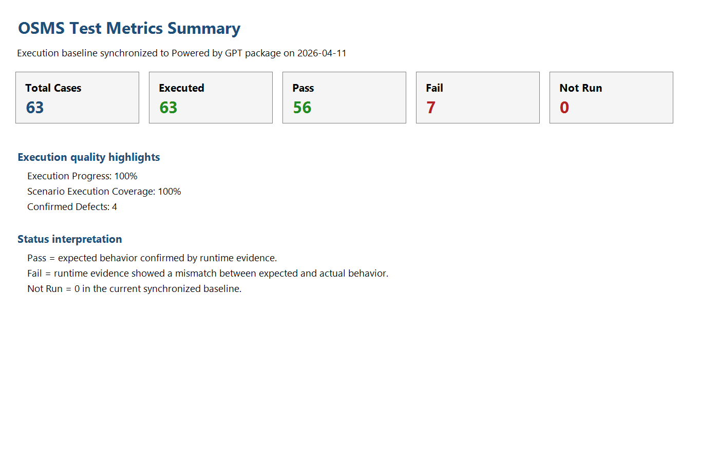
Figure M-1 - Metrics summary

V. Conclusion And Future Work

5.1 Achievements And Compliance
This submission achieved the following:
• completed a source-based project audit rather than a generic theory-based plan
• defined a structured test plan, scenario set, UI/API test cases, and reusable test data
• implemented a real automation framework for UI and API testing
• captured real execution evidence for both UI and API
• prepared a professional defect-management package and metrics pack
• maintained clear traceability between scenarios, test cases, results, evidence, and observations

5.2 Challenges And Limitations
The main limitation of the current package is no longer execution depth. All 63 designed test cases now have real runtime evidence. The remaining limitation is unresolved defect count: the system still contains four confirmed defects across invoices, purchases, and product import. All four defects are now mirrored into live GitHub Issues, and the invoice-create defect remains the strongest case because it also has server-log proof. Because of this, the report still cannot responsibly claim that the full system is stable.
The package still lacks two completions that would improve its final polish:
• focused defect retests were executed again on 2026-04-11, and all four confirmed defects still reproduced without any status downgrade
• basic cross-browser evidence now exists through an Edge smoke rerun of TC-UI-AUTH-001

5.3 Future Enhancements
The highest-priority next actions are:
1. fix and retest the invoice-create defect tracked in GitHub Issue #1
2. fix and retest invoice cancellation, purchase validation rendering, and import confirm after fixes are available
3. refresh the defect log, final results workbook, and metrics pack after those post-fix retests
4. expand cross-browser evidence beyond the current Edge smoke proof if time permits

5.4 Final Conclusion
Based on the current execution evidence, the Online Sales Management System now has full case-level execution coverage across the designed UI and API test suite. The package is strong in test design, evidence traceability, and automation support, and it now avoids the earlier weakness of large Not Run sections. The automation evidence is also stronger because a basic Edge smoke rerun now confirms TC-UI-AUTH-001 outside the primary Chrome baseline. However, the system still contains four confirmed defects, all mirrored into live GitHub Issues, and the invoice-create defect remains the strongest defect because it combines UI proof with server-log proof. Focused retests on 2026-04-11 showed that those four defects still reproduce, so the most defensible conclusion is that the project is execution-complete and submission-ready, but still short of a maximum-confidence quality claim until those confirmed defects are fixed and pass post-fix retest.

References
1. MainReport/UEF - Final.pdf
2. MainReport/SupportingDocs/phase-0-project-audit.md
3. MainReport/SupportingDocs/test-plan.md
4. MainReport/SupportingDocs/test-scenarios.md
5. MainReport/SupportingDocs/phase-7-automation-design.md
6. MainReport/SupportingDocs/phase-9-execution-and-evidence.md
7. MainReport/SupportingDocs/phase-10-defect-log-and-bug-management.md
8. MainReport/SupportingDocs/phase-11-final-results-and-metrics.md
9. MainReport/SupportingDocs/phase-12-analysis-and-insights.md
10. Source repository: https://github.com/Alucard30Dec/Online-Sales-Management-System

Appendix

Appendix A. GitHub Submission Link
• https://github.com/Alucard30Dec/Online-Sales-Management-System/tree/main/Report%20Test%20subject/SV00123-ATU-A01

Appendix B. Key Attached Artifacts
• Main report: MainReport/Powered by GPT - Software Quality Verification - Final Report.docx
• Final PDF: MainReport/Powered by GPT - Software Quality Verification - Final Report.pdf
• Presentation: MainReport/Powered by GPT - Software Quality Verification - Presentation.pptx
• UI test cases: TestCases/UI/OSMS-UI-Test-Cases.xlsx
• API test cases: TestCases/API/OSMS-API-Test-Cases.xlsx
• Scenario file: TestCases/Scenarios/test-scenarios.md
• Automation scripts: TestScript-Data/Automation/
• Test data: TestScript-Data/TestData/
• Final results: TestResults/FinalResults/OSMS-Final-Test-Results.xlsx
• Metrics: TestResults/Metrics/OSMS-Test-Metrics.xlsx
• Defect log: TestResults/Defects/OSMS-Defect-Log.xlsx
• UI evidence: TestResults/Evidence/UI/automation/
• API evidence: TestResults/Evidence/API/newman-full-run.txt
• Video: Videos/OSMS-Automation-Demo.mp4

Appendix C. Remaining High-Value Execution Gaps
• Focused retests on 2026-04-11 confirmed that all four live defects still reproduce; true post-fix retest evidence is still required.
• Basic cross-browser evidence is now included through an Edge smoke rerun for TC-UI-AUTH-001.

